**GSUtil Manual**

The gcs.sh file is a bash script which is to be run from the cmd/shell (where gcloud has been set up)

This document serves as a POC for gsutil command usage remotely.

**STEP 1:** gcs.sh login

This is a sample run of my Google Storage access id and secret key credentials. These credentials will be stored in a .boto config file.

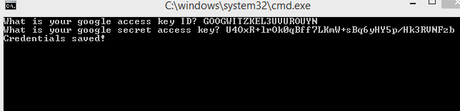

**STEP 2:** Once you have logged in with the correct credentials, you can execute gsutil commands from the gcs.sh script. You can run the following commands:

gcs.sh create

gcs.sh upload_file

gcs.sh upload_folder

gcs.sh download_file

gcs.sh list

gcs.sh delete

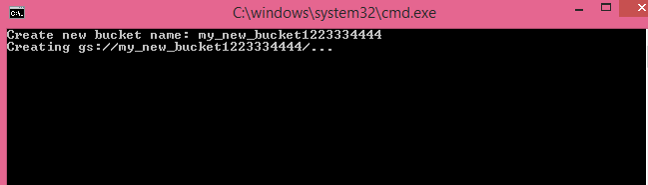

Figure 1 Create new bucket

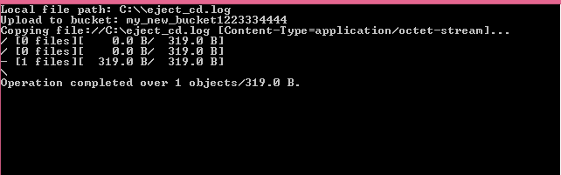

Figure 2 Upload file to bucket

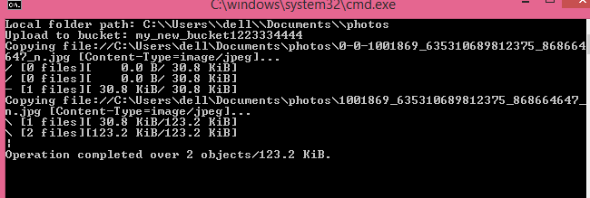

Figure 3 Upload folder to bucket

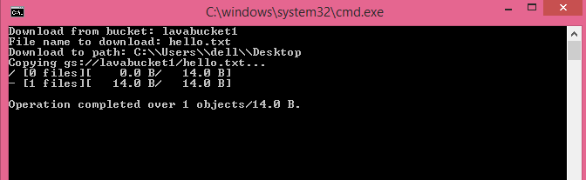

Figure 4 Download file from bucket

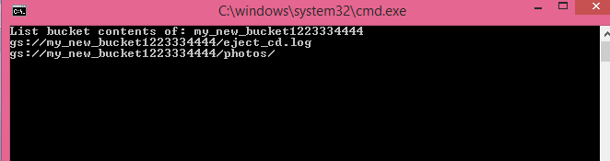

Figure 5 List bucket contents

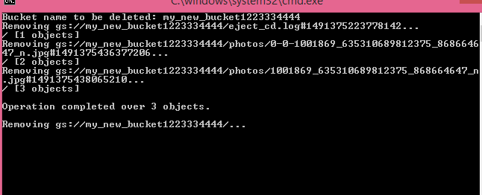

Figure 6 Delete bucket